Work through wish list until done

Search !!! (your marker) for your incomplete functions)

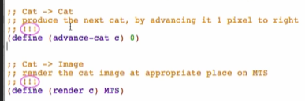

For advance-cat

**Examples**

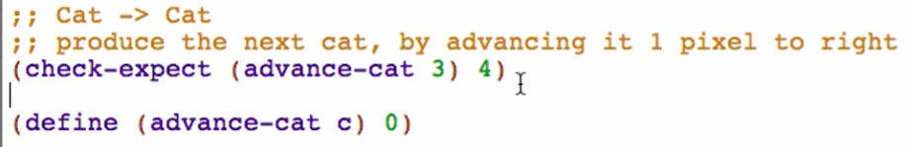

Run to see if well-formed

**Template**

Comment out stub, use template from Cat (data definition), rename the template function name

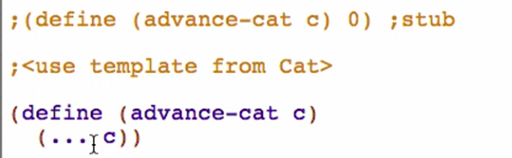

**Code body**

Fill in the template

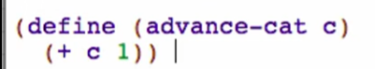

Try running and check if passed

For render

**Examples**

(place-image [img] [x-coord] [y-coord] [bg])

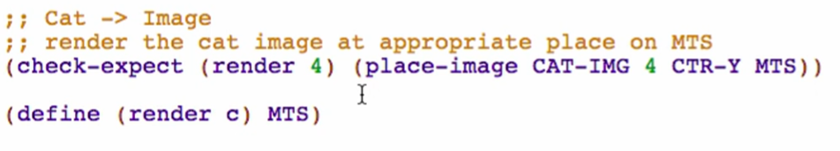

Note: time spent on examples isn’t a delay! It’s more likely time saved when you’re designing the function code body itself

Run to see if well-formed

For render functions, look at the expected result

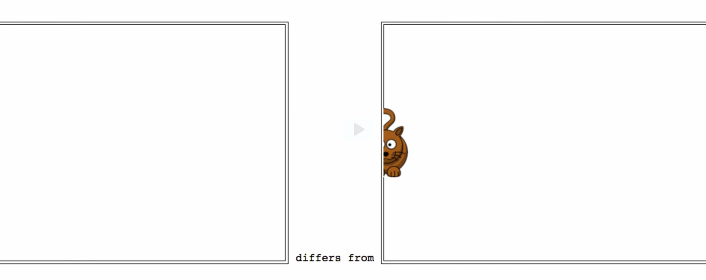

This is to see if our test/example makes sense

**Template**

Comment out stub, use template from Cat (data definition), rename the template function name

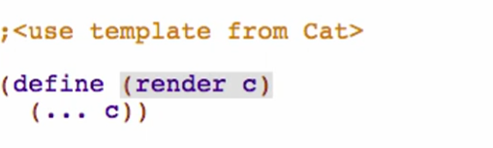

**Code Body**

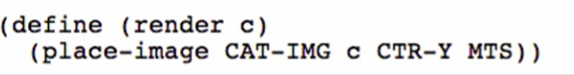

Try running and check if passed

Running the world program:

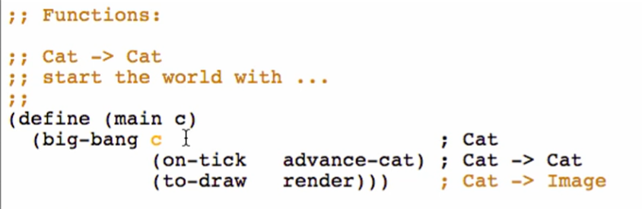

Run the program, and then on the interaction window, call the main function with an argument of your x-coord

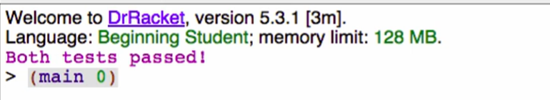

We can also specify in our purpose at the world function to what your first argument (first state) can start (default value)

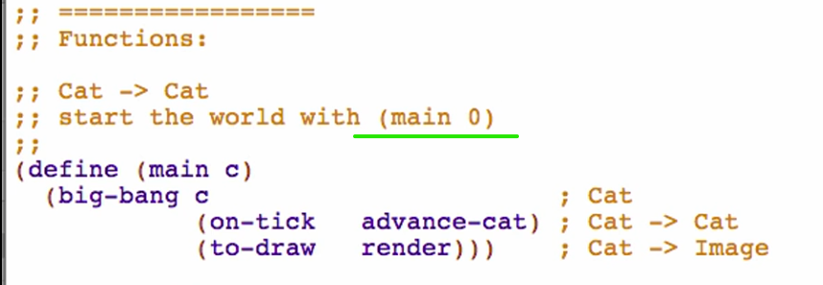

Note:

* Systematic process
  + This lets you work one thing at a time and know it’s all gonna work out
  + Not all elements/parts of the process will show in your function definition
    - Eg. our domain analysis which only exists on paper but this is the start of our systematic process and really helped us to work our way through